

CAMBRIDGE MEMORIAL HOSPITAL

2/16/2025

E-PROJECT

KISHWAR JEHAN

FACULTY

AI-202408-D

BATCH CODE

ACHIEVEMENT ACKNOWLEDGEMENT

In recogination of outstanding dedication and proficiency, we proudly acknowledge the successful completion of the assigned task by the following students during the ACCP AI semester at Aptech learning Shahrah-e-faisal. Guided by the esteemed faculty, Miss Kishwar Jehan,these individuals have showcased commendable skills and commitment:

* SHAFQATULLAH Student 1602486
* MUBASHIR HUSSAIN Student 1602487
* ANAS ALI Student 1602398

This achievement stands as a testament to their hardwork and proficiency , reflecting positively on their academic journey . Congratulations to the students of batch AI-202408D TTS for their remarkable accomplishment.

INNOVATION IN LEARNING:

EMBRACING TECHNOLOGY

In the dyanamic realm of the IT industry, the imperative for

Continual learning and practical application is more pronounced

than ever . Professionals face challenges such as demanding

schedules and geographical constraints , hindering the seamless

translation of acquired knowledge into practical scenarios. These

challenges are equally felt by our students , graphing with busy

schedules and the ever-present need for hands –on experience ,

particularly in the swiftly changing landscape of IT education.

In response to these hurdles, Aptech is unwavering in its commitment to redefine the learning experience. Introducing a progressive approach , we harness technology to create a live and synchronous e-project learning environment. This innovation solution not only dismantles traditional barriers but also empowers students to actively engage with and apply concepts in real- time. As we embark on this transformative journey , our focus remains on leveraging technology to elevate our training model , ensuring our students not only keep pace with technological advancements but also play a pivot role in shaping the future of IT education.

UNVEILING E-PROJECT : YOUR

GATEWAY TO PRACTICAL LEARNING

E-Project is not just a learning environment : it’s a meticulous , step by step simulation seamlessly mirrors the traditional classroom and lab – based setting , transforming theoretical knowledge into tangible implementation .consider it as project implementation at your fingertips – a dynamic , electronic interface on the machine designed to empower you to:

* Practice through a systematic , step- by-step , laddered approach.
* Construct more expansive and resilient applications .
* Utilize specific utilities within user- designed applications .
* Learn the phased implementation of concepts.
* Elevate skills and add substantial value pf our expertise.
* Engage in real-life projects that mirror authentic scenarios.
* Tackle more complex and meaningful application development .
* Benefit form mentoring through dedicated email support.

E- Project is not just a tool ; it’s your partner in mastering practical application , offering a transformative learning experience.

Problem Statement

Cambridge Hospital is one of the famous hospital in the town since 1928, now the

hospital organization wish to change their existing website completely. The website

which they demand is suppose to provide user friendly environment and navigation.

The important menu must be stated in the top section of the webpage. Also a decent

look out and color combination is expected.

Requirement Specification:

The Web site is to be created based on the following requirements.

1) The Home Page with some description about the Cambridge Hospital like who

is the founder and some of the achievements of handling critical cases.(Also

navigational link must be included.)

2) The website must provide information like “About us”, “Department”,

“Facility”, “Services”, “Centres”, “Academic”, “Contact Us”, “Vacancies”,

”Query”, Feedback”, “Success Stories”.

3) Each section must provide brief information.

4) Also each link must be properly hyperlinked, images must be used wherever

necessary.

5) Contact Us page must flash the address of all the location where the hospital

is located.

6) Department details like “helpdesk”, “registration”, “Doctor Schedule”, Billing

and Accounts” and so on must be included.

7) Facility like “rooms”, ICU”, Medical Facility”, “Other Facility”.

8) Services like “general services”, “Health Checkup”, “Specialties” and so on.

9) Centres like “diagnostic centre”, “cancer centre”, “heart centre”, “community

health centre”.

10) Feedback must be taken.

11) Query must be allowed to enter.

HOME PAGE

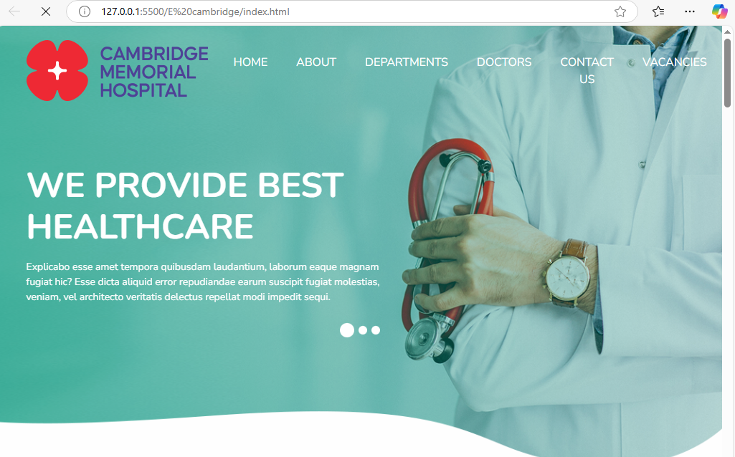

Our home page is made with the help of HTML5 and its styling with CSS we have added some images with slider

OUR DEPARTMENTS

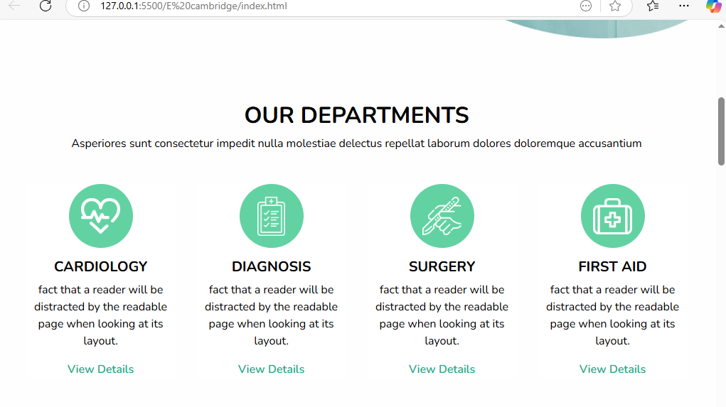

In department section we have added some health related departments

ABOUT US

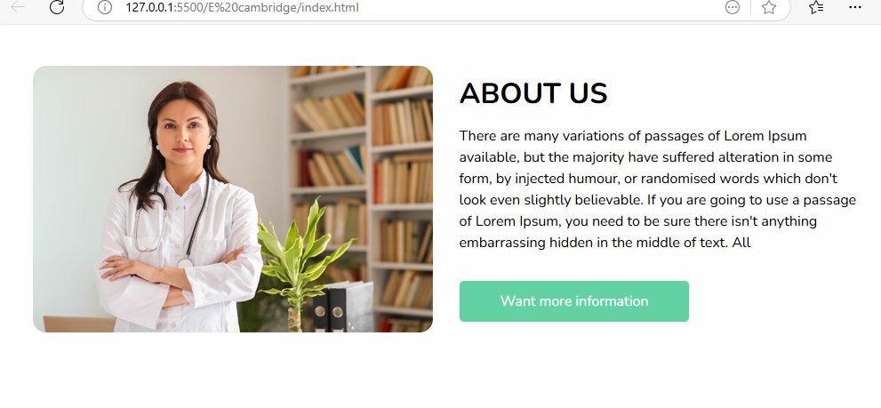

About us section has some information about the hospital

OUR DOCTERS

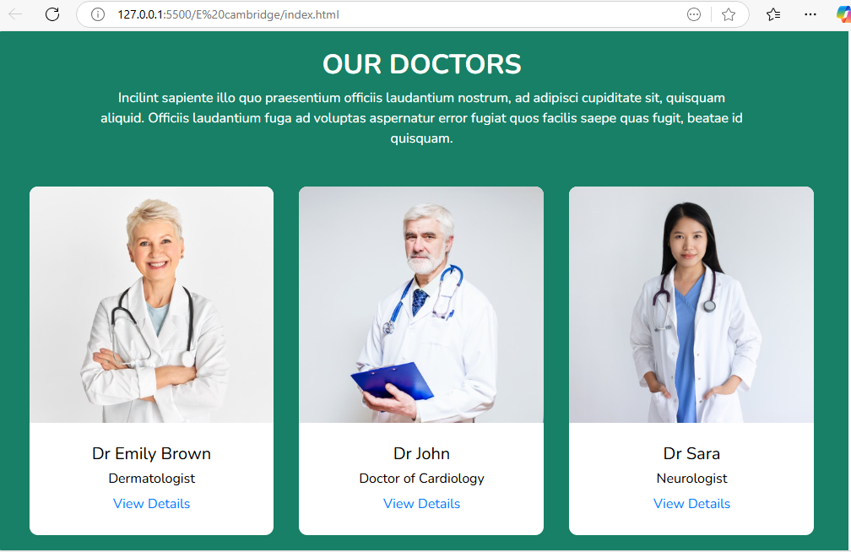

Cambridge hospital have experienced doctors

PATIENT REVIEW

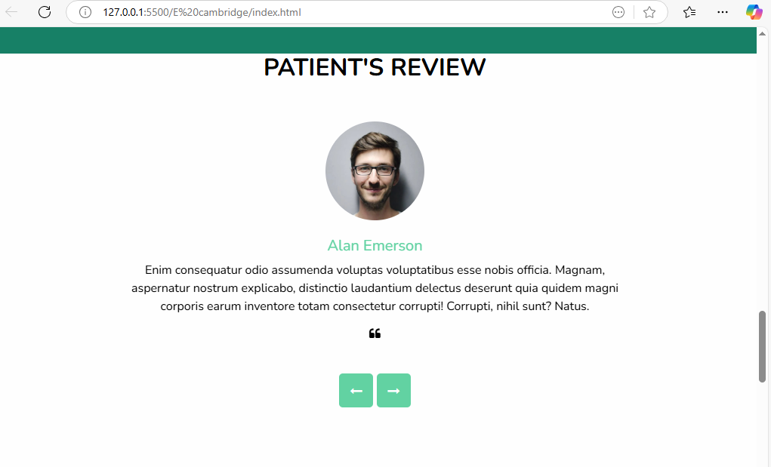

Our patients review are added on Patient Reviews

FOOTER

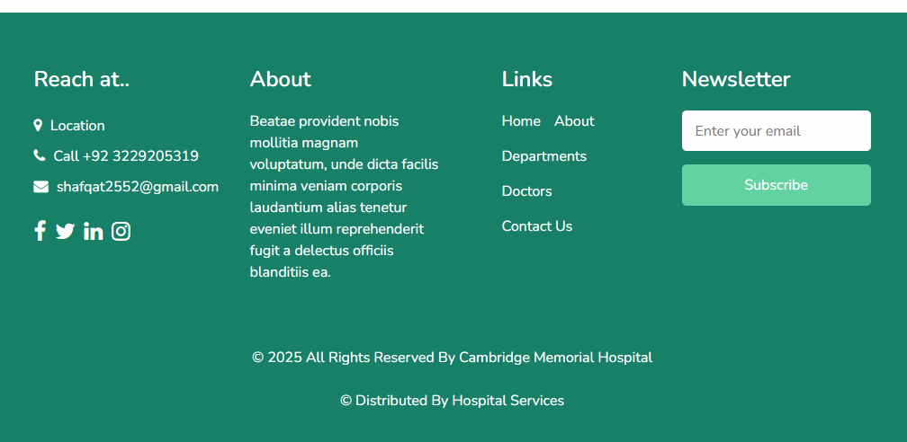

In the footer we have added some about us and some links

HTML CODE

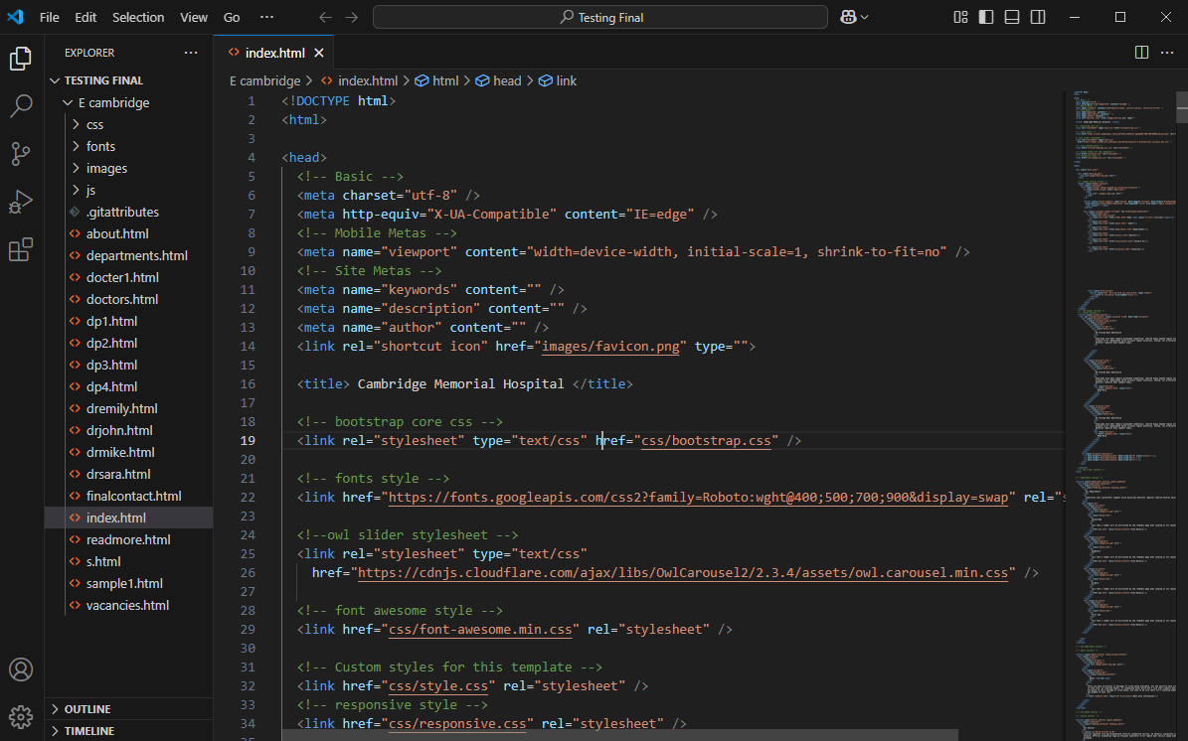

HTML CODE 2

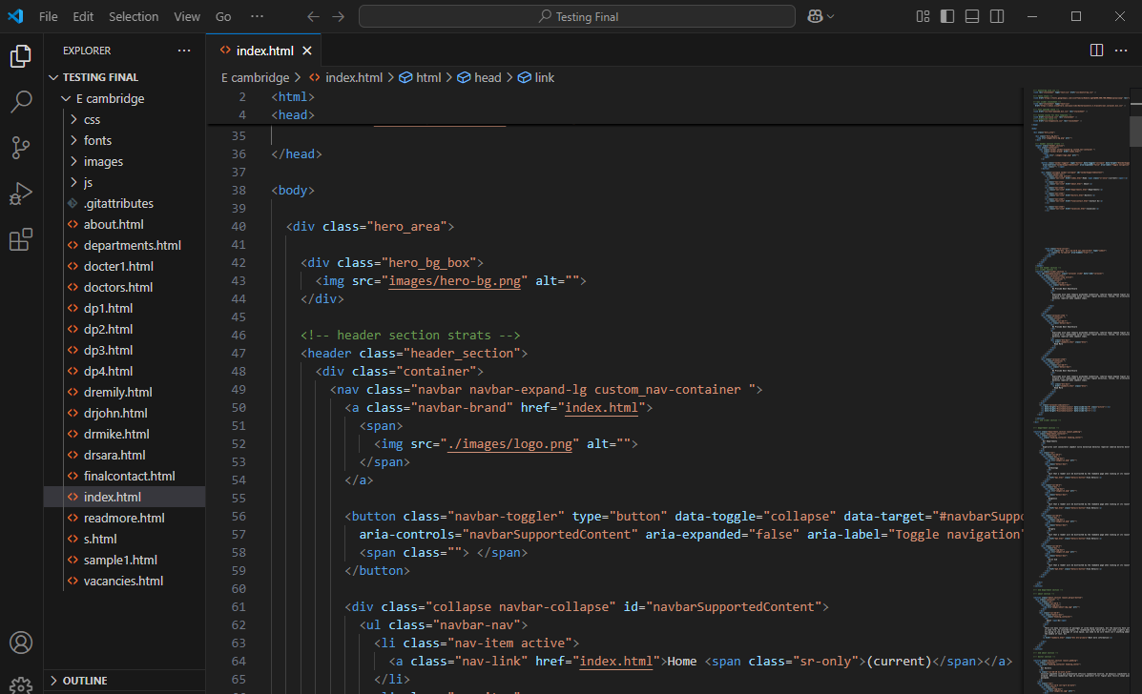

CSS CODE